1.30- 4pm Saturday 9th March

Rest.

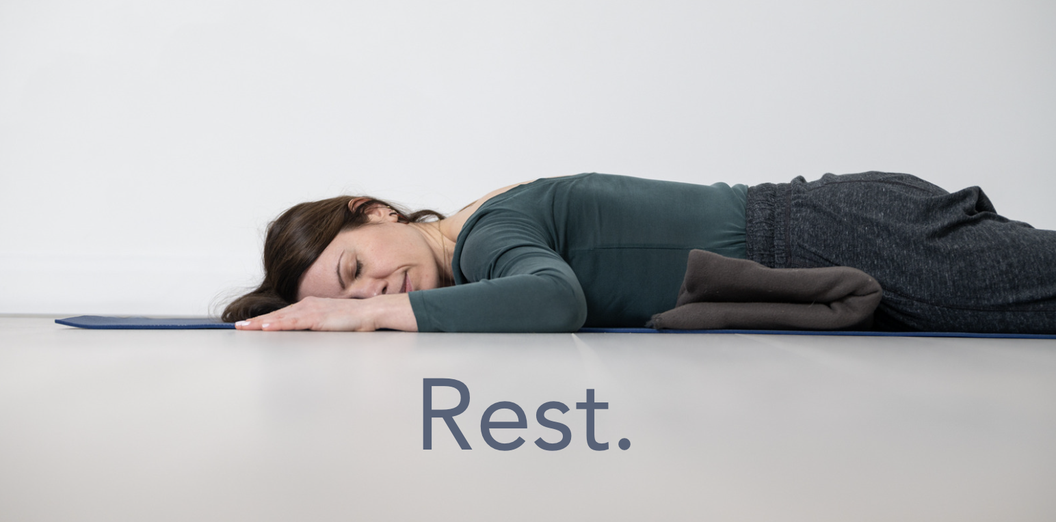

This workshop explores how we get from busy to rest.

For those drawn to active and dynamic asana, restorative practices are often overlooked, but this subtle and powerful practice is a doorway to necessary rest. We often consider rest a luxury and so many of us find it hard to truly take the time to do nothing.

In this workshop you will:
- Learn how to prepare for rest through gentle somatic-inspired movement
- Approach movement that moves beyond traditional principles of alignment
- Explore hacks to help you get to a state of rest quicker
- Use props to help you rest in a supported and comforting way

Restorative yoga and somatic movement are a great combination of practices. They are a great way to work with fatigue, stress, insomnia and anxiety. The deep state of rest practiced and Restorative yoga helps boost the immune system and balance the nervous system, and the best part is it’s suitable for everybody.
You can find out more about Sarah at www.sarahwilliamsyoga.com

£35/£30

